General Technologies & Hangarau

Level 3, 6 Credits, Internal Assessment

Student Documentation

This document serves as evidence of your work for **AS 91610: Develop a conceptual design considering fitness for purpose in the broadest sense.**

# Instructions

Edit the header and replace the underlines with your full name and NSN (you can find this on PCSchools under Student Information).

You must attach relevant images (wireframes, mock-ups, screenshots, etc.) into each section of the document. You must also include a high-resolution copy of these images separately.

For your **FINAL** submission, make sure you have included:

1. Your name and National Student Number (NSN) in the header for each page
2. **ONLY** include the information you wish to have marked and moderated

Table of Contents

Instructions 1

RESEARCH: Analysis of existing outcomes 2

Initial Brief 4

Design Specifications – Stakeholder Requirements 5

Conceptual Wireframes 6

Conceptual Design 1 7

Conceptual Design 2 9

Conceptual Design 3 11

On-going Research – Moodboard 13

Social and Physical Environment 14

Functional Modelling – Testing 15

Legal, Ethical & Moral Considerations 16

Conceptual Design Development 18

Final Brief 20

Final Conceptual Design 22

Final Conceptual Design in Context 22

Conceptual Design Evaluation 23

# RESEARCH: Analysis of existing outcomes

## Looking at existing websites

Include all of the research into the existing website experiences and designs you have done.

## Duolingo – Language learning tool

|  |  |
| --- | --- |
| **Visibility of system status** | |
| Progress bar at the top to let the user know how far into the test they have progressed  A result, with checkmark and green background, to let the user know how they have done on this question  The person picture is smiling. This means the user answered correctly. If they were frowning, the user answered incorrectly. |  |
| **Match between system and real world** | |
| Nav bar at the top have icons which the user will clearly associate with the related link. Such as a chat bubble for the discussion tab and a store front for the online shop. They also have a book with a magnifying class for the Dictionary tab due to the fact you will be looking for a specific word. | |
| **User control and freedom** | |
| While in a lesson they have a clear skip button and exit button all in places that the user would expect to find them as well. | |
| **Consistency and standards** | |
| Constant nav bar at the top of the screen, with all of the standard nav bar items, such as links and user account specifics |  |
| **Error prevention** | |
| As you can see here, Duolingo also has error prevention in the form of a log in system. I was not able to log in using an invalid account. |  |
| **Flexibility & ease of use** | |
| Duolingo allows for the user to use the keyboard in order to select an option as well as using the mouse as the standard. |  |
| **Aesthetics and minimal design** | |
| As you can see Duolingo really acts on this Heuristic. Their site is quite minimal, only including the key aspects and doing so in a manor that isn't right in the user's face. |  |
| **Help users diagnose & recover from errors** | |
| Here we have an error dialog box that pops up when you are trying to exit out of an activity. This happens just in case you clicked the exit button by mistake in order to prevent you from loosing your progress through out the activity. |  |
| **Help and documentation** | |
| At the end of the page, in the footer, there is a link to Duolingo's help site which has documentation describing how to use the site etc...  There is also contact information in that case that the website does not answer the question you have. | |

# Initial Brief

## Context

In 2021, based on consultation with students, staff members, whānau, and the local community, Onslow College adopted a new set of school values. One of the new values is *whakapapa***:** “*this value is about the layers that make up who we are”*.

This means we acknowledge and celebrate the diverse upbringings, cultures, and backgrounds that each student and staff member bring to the school. As part of that, it is also important to knowledge the history of the school itself, its surrounding *whenua* (area), the peoples who contribute to it, and what Onslow College contributes back to the community.

## Given Brief

You are tasked with designing and developing a website to educate current students about the history of Onslow College, the local area, the *iwi* that make up the area, and relevant terms in *Te Reo Māori* that help explain Onslow College’s *whakapapa* and the surrounding *whenua*.

## Target Market

* Onslow College Students (Year 9 – 13)
* Parents of Onslow College Students
* Teachers & Staff of Onslow College

## Stakeholders

* Matua Doc
* Daniel Stevens
* Callum Stevens
* Shakeel Morar
* Nerissa Linwood
* Tyler Rowe

# Design Specifications – Stakeholder Requirements

## Functionality

We are required to have a total of 5 quizzes/lessons

* Each quiz question must have a: question, 1 correct answer with 2 incorrect answers
* Each quiz topic must have a total **question pool** of 15 questions
* The quiz will randomly pick 10 of those questions to be presented during each round
  + 5 Multi Choice & 5 Text Based
* ­­­­A high-score will be recorded and saved to the database along with a user’s initials/name
  + Only store the top 100 scores for each quiz along with time and date. Display on site

Needs to be coded according to Spaced Repetition Software conventions

* If a user gets a question wrong, it's added to the back of the queue to be asked again later
* Only questions answered correctly on the first try are scored
* Students need to be made aware of the questions they got wrong, along with the correct answer

### Design (visuals)

* Onslow College branding/colour scheme is not necessary but won’t be disallowed.
* Prefer a more serious and/or professional tone to the website
* The website needs to be accessible. Low-vision users should be able to access the data and use the quizzes
* The fonts should be accessible as well. We need to reduce the difficulty for students with dyslexia as much as possible
* Text must be sufficiently legible

### Data

* Questions and answers will be supplied along with some images
* The focus of the website should be the information and the quiz in equal parts, not one over the other

### Technological

* You may host your website on Pricilla or by your own means as long as its accessible

### Budget

* Free / Self-Financed (student made)

# Conceptual Wireframes

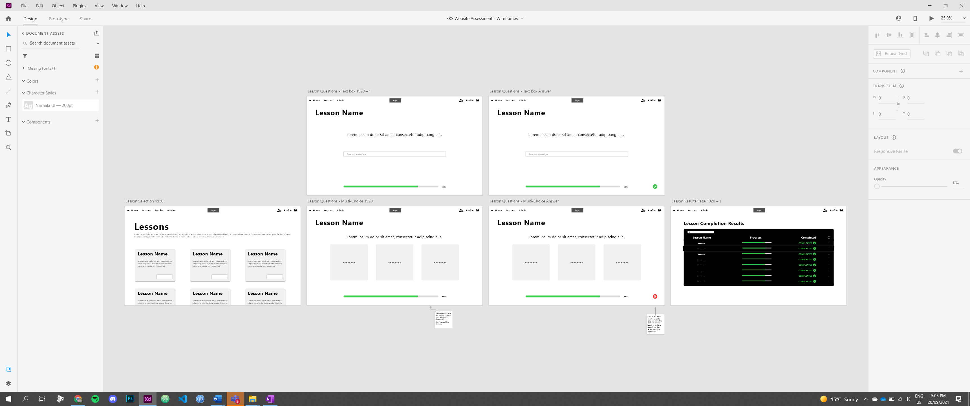

# Conceptual Design 1

## Pros of the Mock-Up

The mock-ups for the quiz screens (multi-choice & text box answers) look very clean, no clutter and the essential buttons are clearly visible. I’d assume that there would be no scrolling on these pages either so that eliminates the possibility for the user to miss a button that’s below the visible screen

## Improvements to the Mock-Up

I think that the quiz selection cards will need to go through a fair amount of iterative development, although they are not shocking they also look like they are at an amateur standard

I also think that the colour schemes accent colours should also go through some iterative development. In my opinion, the accent colours are too vibrant which would be fine for something like a question indicator (telling the user weather they answered correctly or not)

## Other Feedback

Bar the development needed for some of your components I don’t have anything else to say for this mock-up

#### *Testing / Feedback*: Shakeel Morar

Looking over the colour scheme above I really like the vibrancy of the red and yellow colours, however do not think that these would quite work as the accents throughout the website. I reckon that they would be better suited for maybe something like a tick and cross that indicates how a student has answered a question or how well they have performed during a quiz (Correct/Incorrect and Pass/Fail maybe)

#### How will you use this feedback to improve the outcome?

I will be taking Shakeel’s feedback on board about the vibrancy of the green and red. Having another look at these shades on one of the wireframe mock-ups I have realised that using them as an indicator accent (indicator accent meaning an accent for a correct/incorrect icon for example) would be a really good idea as the colour is slightly separate from the rest of the websites colour scheme and therefore means it can stand out better.

# Conceptual Design 2

## Pros of the Mock-Up

I really like how the lesson select has an image and the lesson names clearly standout

## Improvements to the Mock-Up

I would suggest including some nice cartoonish icons or illustrations nest to the lesson cards that could be associated with it. Doing this could bring a good professional look to your website if you can find a way to source and incorporate them as well.

## Other Feedback

I do not think that there is much more you can do to develop the quiz questions pages, other than showing the user system status like correct/incorrect answers or showing letting the user know that they need to provide an answer.

#### *Testing / Feedback*: Shakeel Morar

Starting at the lessons page I really like the cards idea however I think that you could develop the way you design them a wee bit more. These currently look very amateur. As for the results page I can see that you’re using the Onslow colours from your first colour scheme. Please do not design a table like this, it does not fit the website. Your quiz cards on the other hand look very good, and I appreciate the little correct/incorrect indication in the bottom right corner.

#### How will you use this feedback to improve the outcome?

Thanks to Shak’s feedback I will now work on developing the lessons and results pages in order to make them more appealing and useable.

# Conceptual Design 3

## Pros of the Mock-Up

I really like how the quiz question pages look. They are not too busy and guide the users attention right towards the questions and answer box/answer making for a perfectly designed page. Keep these pages in the final design.

## Improvements to the Mock-Up

If I were to suggest something, I’d suggest giving the website background. Using one of those blurry neutral glassy backgrounds in order to provide a wee bit of depth without overwhelming the user. would be a good addition as to stop the website from looking too bland. Do not use this unless you can make it look professional, however.

## Other Feedback

I do not like the look of the red gradient background used on the lessons page. Rather keep it a solid colour.

#### *Testing / Feedback*: Tyler Rowe

In my opinion, I do not think that the red gradient goes well as a background. If I were to suggest something as a background, I’d suggest using one of those blurry neutral glassy backgrounds in order to provide a wee bit of depth without overwhelming the user.

Just like the others I really like how the quiz question pages have come out.

#### How will you use this feedback to improve the outcome?

Thanks to Nerissa’s feedback I think I the consensus will be that the quiz question pages should be here to stay as they are simplistic and serve its purpose.

# On-going Research – Moodboard

Here is the moodboard I have put together. It is composed of a range of different designs, images, and colours so give a general sense to how I am looking to design the outcome.

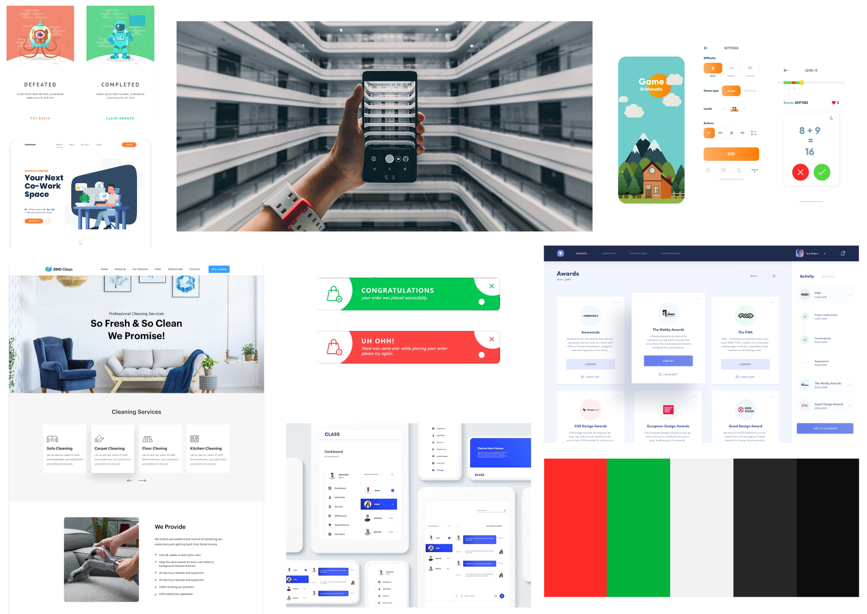

# Social and Physical Environment

## Social Environment

Who is the outcome designed for?

|  |
| --- |
| * Students of Onslow College (year 9 – 13) * Parents of Onslow College students * Teachers & Staff of Onslow College |

**Explain** and **Justify** why these **social** considerations are necessary for the outcome being fit for purpose

|  |
| --- |
| Me must consider students in order to make sure that our outcome is developed in a way that is usable for our audience.  We need to do this to encourage community by sharing history, culture, knowledge of the college and giving a sense of belonging to the students. |

## Physical Environment

Where is the outcome going to be located?

|  |
| --- |
| * Can access via the internet * Can access using a Computer, Laptop, Mobile Device (phone or a tablet) * Can access it worldwide (so long as you also meet the above criteria) |

**Explain** and **Justify** why these **physical** considerations are necessary for the outcome being fit for purpose

|  |
| --- |
| * Connection to the net * Data Consumption * - Information and loading of the website * Security of the data * Age-appropriate content * Compatibility with different form factors E.g. Mobile, standard, ultrawide devices |

# Functional Modelling – Testing

## Usability Testing

|  |  |
| --- | --- |
| Initial Wireframes (Adobe XD) | Annika Munro |
| * Like the way the lessons are laid out – good combination of separating information into boxes/sessions while also not making the user working hard by scrolling down tons to find what they want. * Assuming the box that says logo means just the logo, I would also include ‘Onslow College’ because the layout of that top navigation bar is nice as it is. * The account section of the navigation bar is a little confusing; I would simplify it to make it more obvious. * The progress bars are a great addition – it gives them a sense of accomplishment as they complete the lesson and it’s a good example of one of the heuristics (visibility of system status or something) * Having only one question per page is a good move – very minimalist very clear where they’re supposed to write/click their answer. * Results page very swag. The different colouring makes it super obviously not a question or a lesson * I would add something that shows you after each question how many you got right. And also on the results page add something that shows them not only the lesson progress but how many they got right so they know if they need to redo the lesson again. * The admin tab has potential to be super handy for a teacher – it could give them a list of students they’re in charge of – and their progress and all that. * Drop shadows are cringe u can’t stop me * Made them grey its less horrific now | |

## Contrast Checking

|  |  |
| --- | --- |
| **Initial Colour Scheme 1** | |
| **Colour Blind Safe:** | **Safe** |
| **Contrast Checker:** | Accents:  Red Contrast Ratio: 3.33:1 Suitable for Large Text, Graphics  Green Contrast Ratio: 2.83:1 Not Suitable on background colour  Main Colour:  Text Contrast Ratio: 19.44:1 Suitable for everything |

|  |  |
| --- | --- |
| **Initial Colour Scheme 2** | |
| **Colour Blind Safe:** | **Safe** |
| **Contrast Checker:** | Accents:  Red Contrast Ratio: 3.74:1 Suitable for Large Text, Graphics  Green Contrast Ratio: 4.52:1 Suitable for everything  Main Colour:  Text Contrast Ratio: 13.46:1 Suitable for everything |

|  |  |
| --- | --- |
| **Initial Colour Scheme 3** | |
| **Colour Blind Safe:** | **Safe** |
| **Contrast Checker:** | Accents:  Red Contrast Ratio: 3.88:1 Suitable for Large Text, Graphics  Green Contrast Ratio: 2.33:1 Not suitable on background colour  Main Colour:  Text Contrast Ratio: 14.04:1 Suitable for everything |

# Legal, Ethical & Moral Considerations

## Intellectual property

Another thing I need to think about while developing my design is how I’m going to avoid using someone else's intellectual property. According to <https://en.wikipedia.org/wiki/Intellectual_property> “Intellectual property is a category of property that includes intangible creations of the human intellect.” Websites often include images and other forms of intellectual property in order to give it a more appealing aesthetic design. If the design is not aesthetically appealing, our users will be less inclined to use it and may find it difficult to navigate.

The purpose of my design will be to educate students, parents and teachers about Onslow College’s history, the surrounding whenua (land), local iwi, and Te-Reo Māori terms in an interactive manner. While designing and developing this outcome I must consider whether or not I could be using images that belong to somebody else, meaning it’s their intellectual property. If I did not take this into consideration, I could be facing legal concerns later down the track to do with copyright and or other legal infringements.

To ensure my design does not use anybody's intellectual property that I do not have the right to use, I will only use assets sourced from creative commons outlets such as [undraw.co/illustrations](https://undraw.co/illustrations), [fonts.google.com](https://fonts.google.com/), content I have a licence for or content produced by myself. This will mean every image, illustration, font etc. will either have a licence stating I am aloud to use the asset associated with it or will by my property, meaning I have free range of use. I will also have to make sure I credit the source to the extent the licence outlines. I will also provide links in the code to each of the places I have sourced the images, illustrations, fronts, etc. in order to prove they are free to use and distribute.

## Accessibility

According to the [Cambridge Dictionary](https://dictionary.cambridge.org/dictionary/english/accessibility), Accessibility is “the fact of being able to be reached or obtained easily” as well as “the quality of being easy to understand”. This means that if a website has accessibility they take into consideration people of all different abilities. This means taking into consideration those with a range of colour blindness as well as those who may have low vision.

Throughout the design and development process I must consider the user experience for individuals who have impearled senses. If I were not to take these factors into consideration while developing my outcome I could be excluding individuals who need to use my outcome but cannot, due to their impairment.

To ensure my design caters for those with different abilities, I will make sure the colour scheme I develop is suitable for those potential uses with a range of different colour blindness. The way I will carry this out is through [Adobe Colour’s Accessibility Tool](https://color.adobe.com/create/color-accessibility), which simulates what a range of different colour blind conditions perceive your colour scheme as, as well as their contrast checker.

Lastly I will include a toggleable dark mode for those people that are light sensitive and need to use inverted colours in order to read and use websites comfortably

## Privacy

Lasty while creating my design I will need to take Privacy into consideration. According to dictonary.com privacy is “the state of being free from unwanted or undue intrusion or disturbance in one's private life or affairs; freedom to be let alone”. In a website privacy is a necessary element.

In order to make sure my design follows privacy; I must make sure that I am not publishing any photos of students without their strict permission and the permission of their parents or caregivers.

I must also make sure to provide age-appropriate content as this the social environment includes users in Year 9 to 13. As well as this the collage having its branding on the face of it.

If I were not to strictly follow privacy, I could possibly be facing legal infringements, to do ith using images I do not have permission to use, or issues around age-appropriate content that could possibly bring down the reputation of the collage.

# Conceptual Design Development

#### Home page

For my final Mock-up / Design I have gone through some iterative development and come up with a carousel design for the Lesson Cards. I am intending to have about 3 or 4 (4 in the this design) cards shoring at a time and for them to be scrollable letting the user choose which quiz they want to the do. The carousel should also have an auto feature where it will scroll to the next card every so often.

#### Quiz Question pages

As for the quiz question cards, they have remained relatively the same as the consensus was that they are all good and should be used in the final design.

#### Results page

Then finally moving onto the results page, which could be subject to change during the development stage, however I have kept the style of table as feedback suggested but changed the colour scheme from using both accent colours to using a single accent and a darker neutral colour as to bring the element out of the background.

# Final Brief

## Context

In 2021, based on consultation with students, staff members, whānau, and the local community, Onslow College adopted a new set of school values. One of the new values is *whakapapa***:** “*this value is about the layers that make up who we are”*.

This means we acknowledge and celebrate the diverse upbringings, cultures, and backgrounds that each student and staff member bring to the school. As part of that, it is also important to knowledge the history of the school itself, its surrounding *whenua* (area), the peoples who contribute to it, and what Onslow College contributes back to the community.

## Given Brief

You are tasked with designing and developing a website to educate current students about the history of Onslow College, the local area, the *iwi* that make up the area, and relevant terms in *te reo Māori* that help explain Onslow College’s *whakapapa* and the surrounding *whenua*.

## Target Market

* Onslow College Students (Year 9 – 13)
* Parents of Onslow College Students
* Teachers & Staff of Onslow College

## Stakeholders

* Matua Doc
* Daniel Stevens
* Callum Stevens
* Shakeel Morar
* Nerissa Linwood
* Tyler Rowe

## Design Specifications – Stakeholder Requirements

### Functionality

We are required to have a total of 5 quizzes/lessons

* Each quiz question must have a: question, 1 correct answer with 2 incorrect answers
* Each quiz topic must have a total **question pool** of 15 questions
* The quiz will randomly pick 10 of those questions to be presented during each round
  + 5 Multi Choice & 5 Text Based
* ­­­­A high-score will be recorded and saved to the database along with a user’s initials/name
  + Only store the top 100 scores for each quiz along with time and date. Display on site

Needs to be coded according to Spaced Repetition Software conventions

* If a user gets a question wrong, it's added to the back of the queue to be asked again later
* Only questions answered correctly on the first try are scored
* Students need to be made aware of the questions they got wrong, along with the correct answer

### Design (visuals)

* Onslow College branding/colour scheme is not necessary but won’t be disallowed.
* Prefer a more serious and/or professional tone to the website
* The website needs to be accessible. Low-vision users should be able to access the data and use the quizzes
* The fonts should be accessible as well. We need to reduce the difficulty for students with dyslexia as much as possible
* Text must be sufficiently legible

### Data

* Questions and answers will be supplied along with some images
* The focus of the website should be the information and the quiz in equal parts, not one over the other

### Technological

* You may host your website on Pricilla or by your own means as long as its accessible

# Final Conceptual Design

# Final Conceptual Design in Context

# Conceptual Design Evaluation

## I have chosen this final conceptual design because

I have chosen this final conceptual design because it is the most refined design I have produced during the project. I have used a range of feedback, such as user/stakeholder feedback to further refine my design.

## Justify how the final conceptual design meets the specifications of the brief

I have followed the stakeholders’ specifications by creating a website designed to use spaced repetition software for to better the users understanding of given topics.

Under functionality I have:

* Included 5 quizzes/lessons
* Each multi answer page including 1 correct answer and 2 incorrect answers
* A page to display results and record the players high scores

Under Design I have

* Used Onslow College branding and seen fit
* Conveyed a serious and professional looking tone across the website
* Considered the accessibility for all users by performing a range of colour and font tests

## How does my final conceptual design address legal, ethical, and moral considerations?

#### Intellectual property

I have taken Intellectual Property into consideration and avoided facing any infringements by:

* Sourcing all my illustrations from an open-source illustration library known as [undraw.co](https://undraw.co/illustrations).
* Using fonts provided by Google which also comes with an open-source licence
* As well as creating any and all images used throughout the conceptual design. With the exception of the Onslow College Logo for which I have received permission from Mātua Doc.

This means that my chosen design doesn’t not contain any copyright/intellectual property infringements.

#### Accessibility

I have also taken Accessibility into consideration; I have done this by:

* Improving visibility by contrast checked the colour scheme used in the conceptual designs
* Improving visibility by colour blind checking the colour scheme used in the conceptual design
* Performing usability and user feedback on the designs, then improving on them where necessary
* Implemented a link strategy (describing the link before inserting it. E.g. at their website)

This means that my chosen design is suitable for all users including those with impairments.

#### Privacy

Lastly I have also taken Privacy into consideration, and I have don’t this by:

* Only using illustrations and images I have the strict permission to use
* Making sure that all the content on in the design is age appropriate as to fit with the social environment

## How did testing inform the development of your conceptual design?

Testing was a vital part in the development of this conceptual design outcome. Using feedback provided through User and Usability Testing helped with refining the design and making it more user friendly. Testing was also a necessary part in creating a more accessible design as I was able to get feedback from a wide range of people including some with impairments such as low vision and dyslexia.

## What are the physical and social environments you considered to develop your final conceptual design?

I designed the conceptual design outcome with a range of Physical and Social environments in mind.

The physical environments include:

* Anywhere you can access the internet
* Anywhere you can access a Computer, Laptop, Mobile Device (phone or a tablet)
* Anywhere worldwide (so long as you also meet the above criteria)

As for the social environment, this includes:

* Students of Onslow College (year 9 – 13)
* Parents of Onslow College students
* Teachers & Staff of Onslow College